User Guide for Knowledge check v2

- To start your knowledge check you need to access knowledge check webserver from your web browser.
Location of the web server and port will be specified by administrator.
- In case, that you will try to connect to knowledge check server before the start of exam you will get following prompt, just wait until the exam will started by administrator and reload your page:

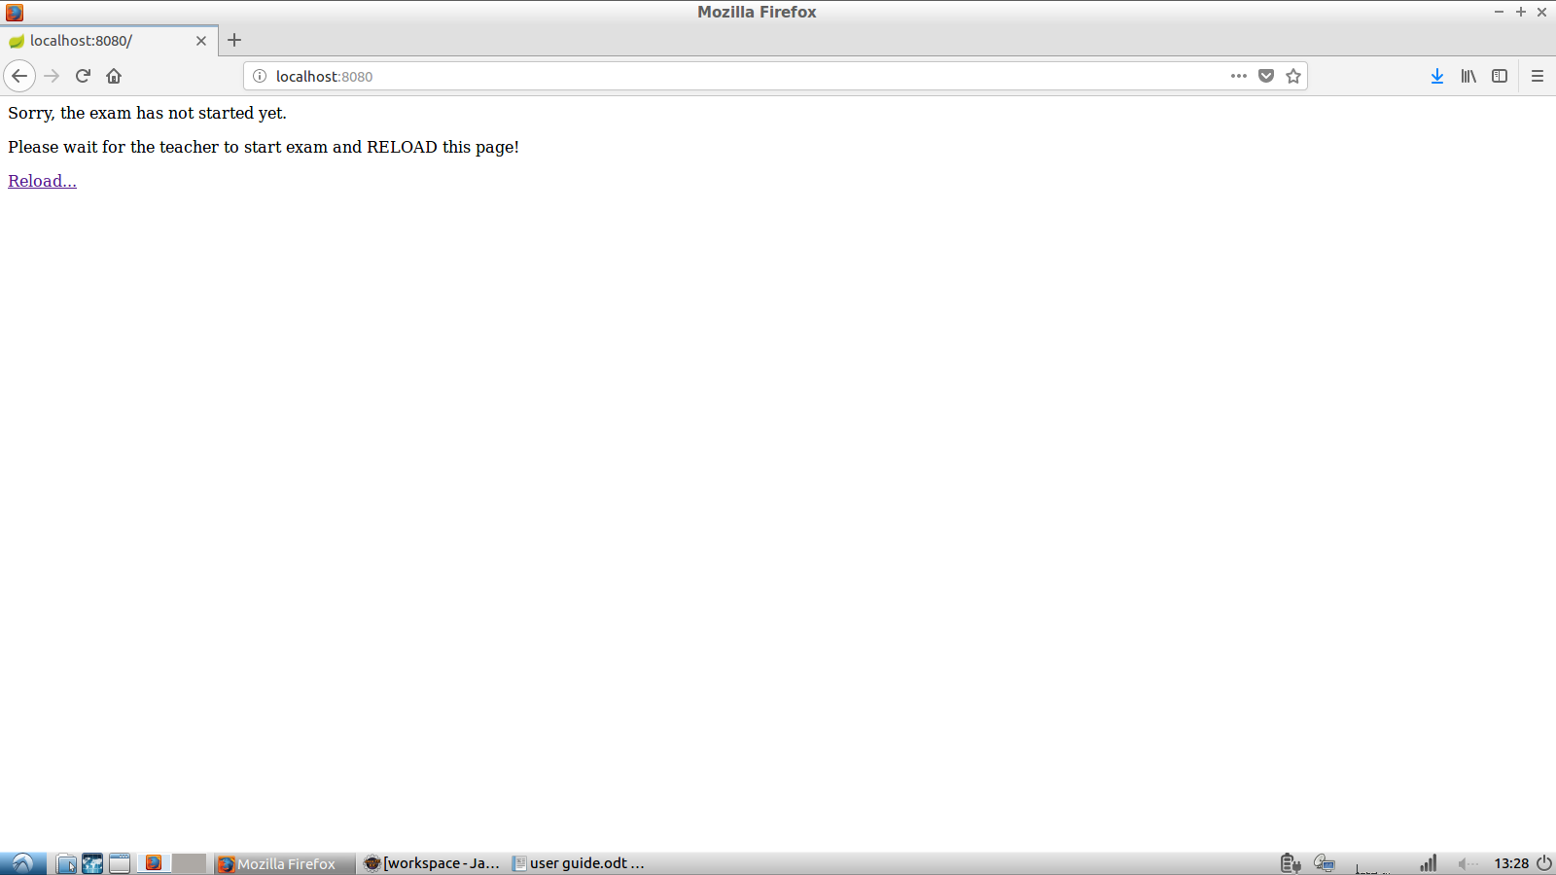
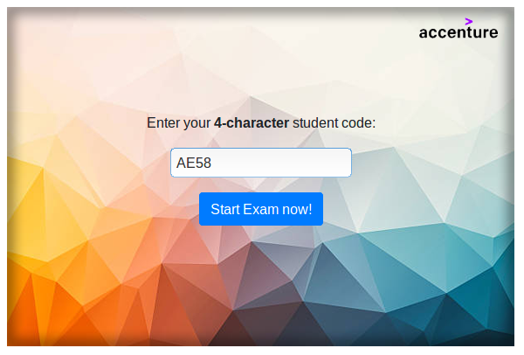
- After the start of the exam you will need to enter you unique code, that has been generated in earlier tasks.

- Please note, that you cannot access exam session second time. If you will try to enter your unique code second time you will get following prompt :
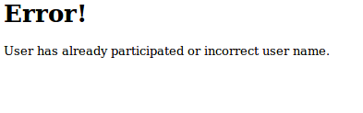

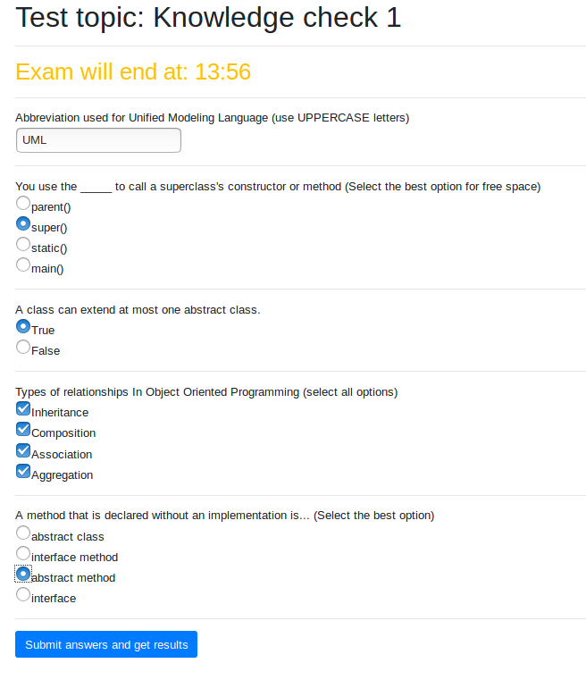
- After entering your unique user code your exam session will start. Here is the example of your exam session :

Please note that you cannot submit your answers after the deadline, and your score for this exam will be 0.
- Just answer all necessary questions and press Submit answers and get results, to get your exam score. You will get the information about your score, number of correct/incorrect answers, and question numbers with incorrect answers.
